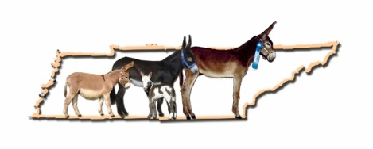
Tennessee Donkey Association
Applies to all Non NMDA Sanctioned Shows
During the Spring meeting on March 29, 2014, a motion was made (motion was passed and voted on by TDA members via Survey Monkey – 85% voted to accept) to adopt the NMDA Show Rules for all classes as the show rules for Tennessee Donkey Association (TDA) shows. With the following exceptions:
1) TDA will allow non-NMDA judges for shows that are not NMDA sanctioned.
2) TDA will not enforce the dress code outlined in the NMDA rules. The current TDA dress code will be used.

TDA SHOW ATTIRE
The show chairperson will have the discretion to determine “good taste”.
- Show attire is to be neat and in good taste.

- Footwear must be solid – no open toes. Boots are preferred. In “game” classes, tennis
shoes are allowed (example: panty race, lead race, coon jumping, etc.).

- Short sleeve or sleeveless shirts may be worn, especially in very hot conditions. T shirts will be allowed as long as the shirt does not have any writing, pictures or advertisements.

- Pants must be long (ankle length).

- Hats may or may not be worn. Baseball caps are allowed as long as they are in good taste.

- Gloves are strongly recommended, but are not required.

- Show attire for a Costume Class does not have these restrictions. However, no skimpy or revealing clothing may be worn.

3) If a participant is rendered "eliminated" per NMDA rules for the class, the participant will be allowed to finish the class. No score will be given for the class. 4) TDA will allow non-registered donkeys to show.
4) TDA will allow non-registered donkeys to show.

